Supplementary Figures

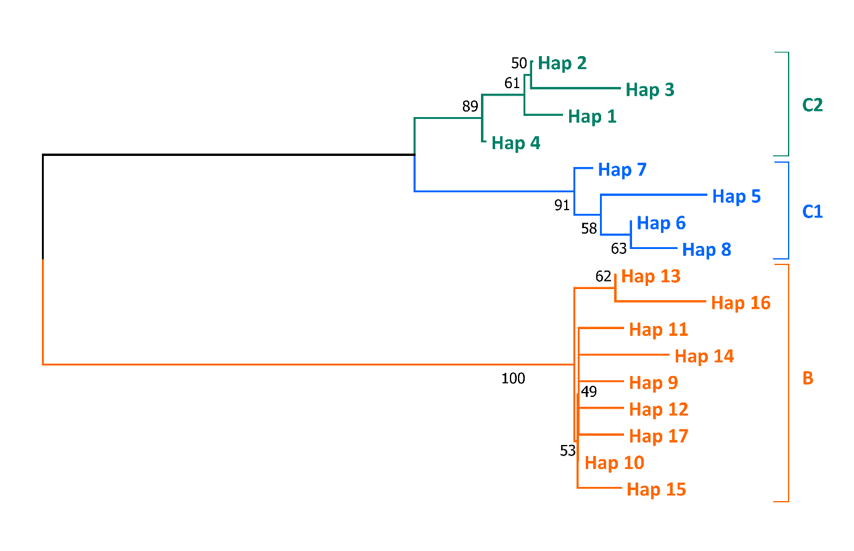
Supplementary Figure 1 – The neighbor-joining tree for M. capaccinii. The bootstrap support values are given on the nodes.

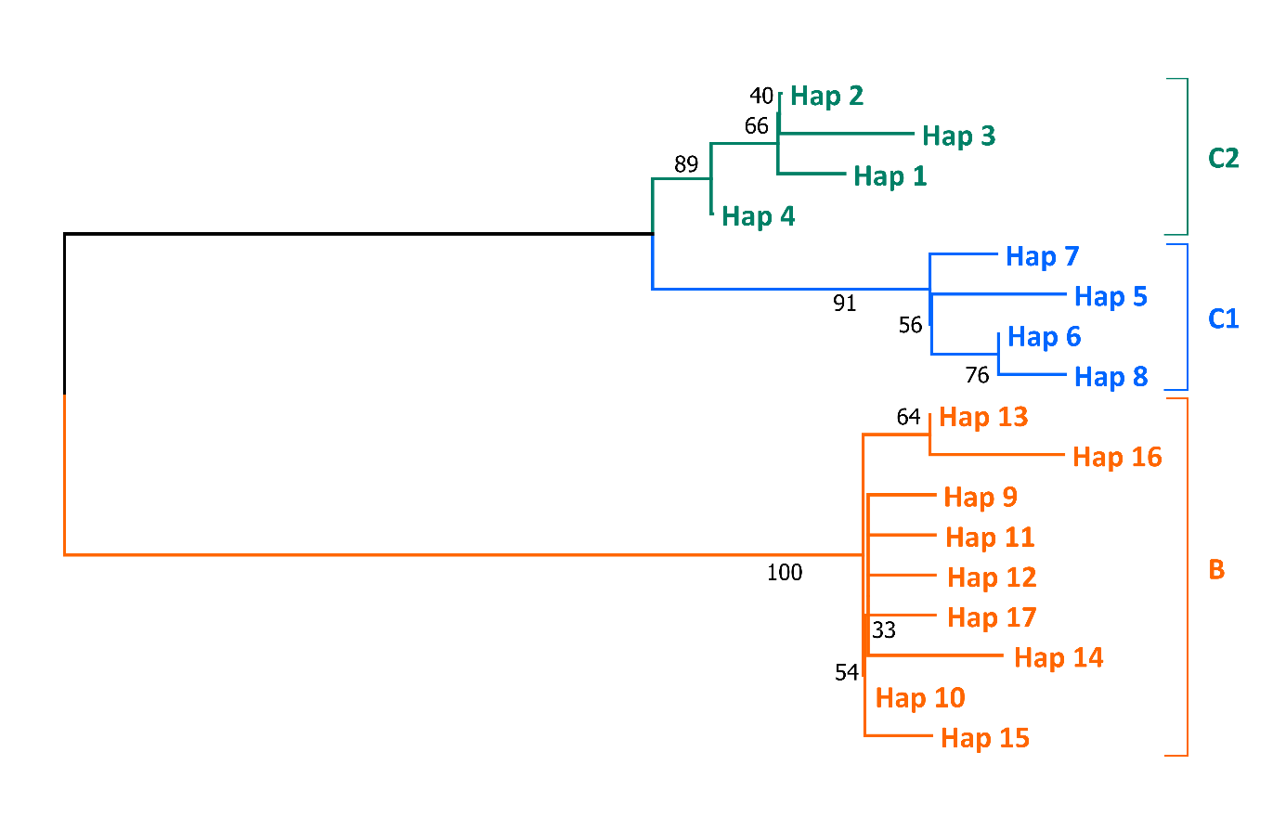
Supplementary Figure 2 – The maximum likelihood tree for M. capaccinii. The bootstrap support values are given on the nodes.

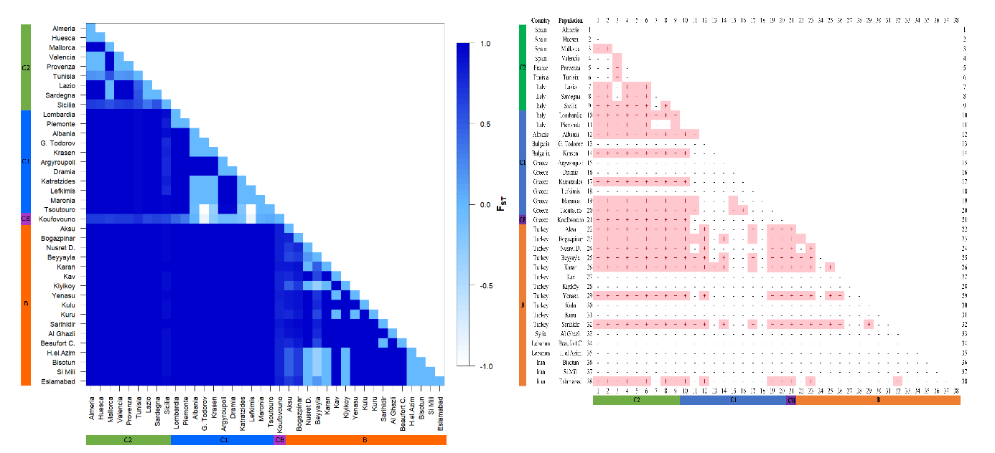
Supplementary Figure 3 – a) F_{ST} values for 38 populations and three clades of M. capaccinii. The color codes of the clades correspond to those on Figure 1. b) The significance of the F_{ST} values. The color codes of the clades correspond to those on Figure 1.

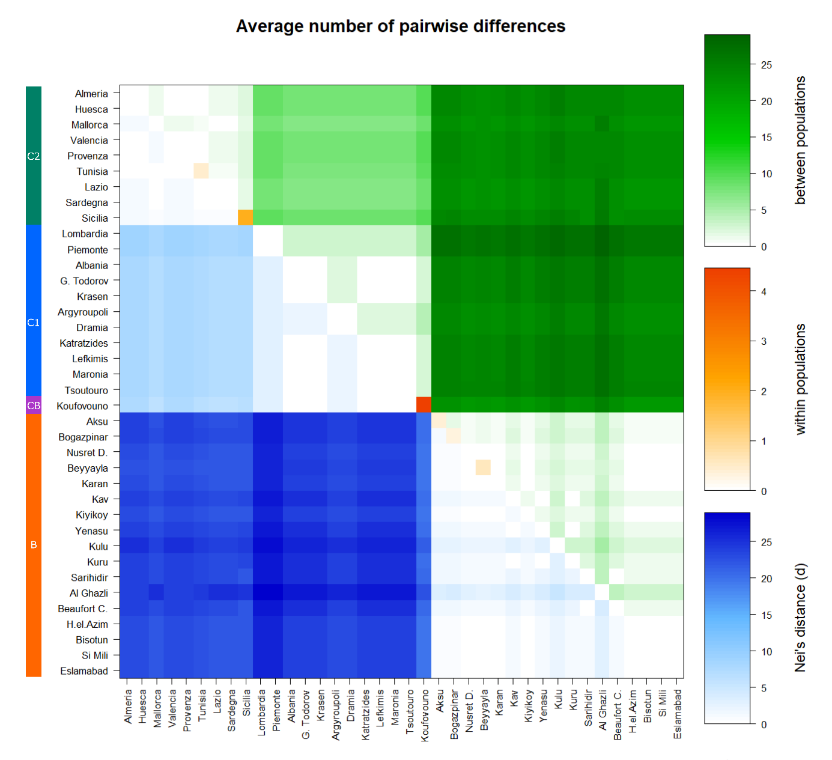
Supplementary Figure 4 – Nei’s distance and average number of pairwise differences within and between 38 populations of M. capaccinii based on mtDNA.

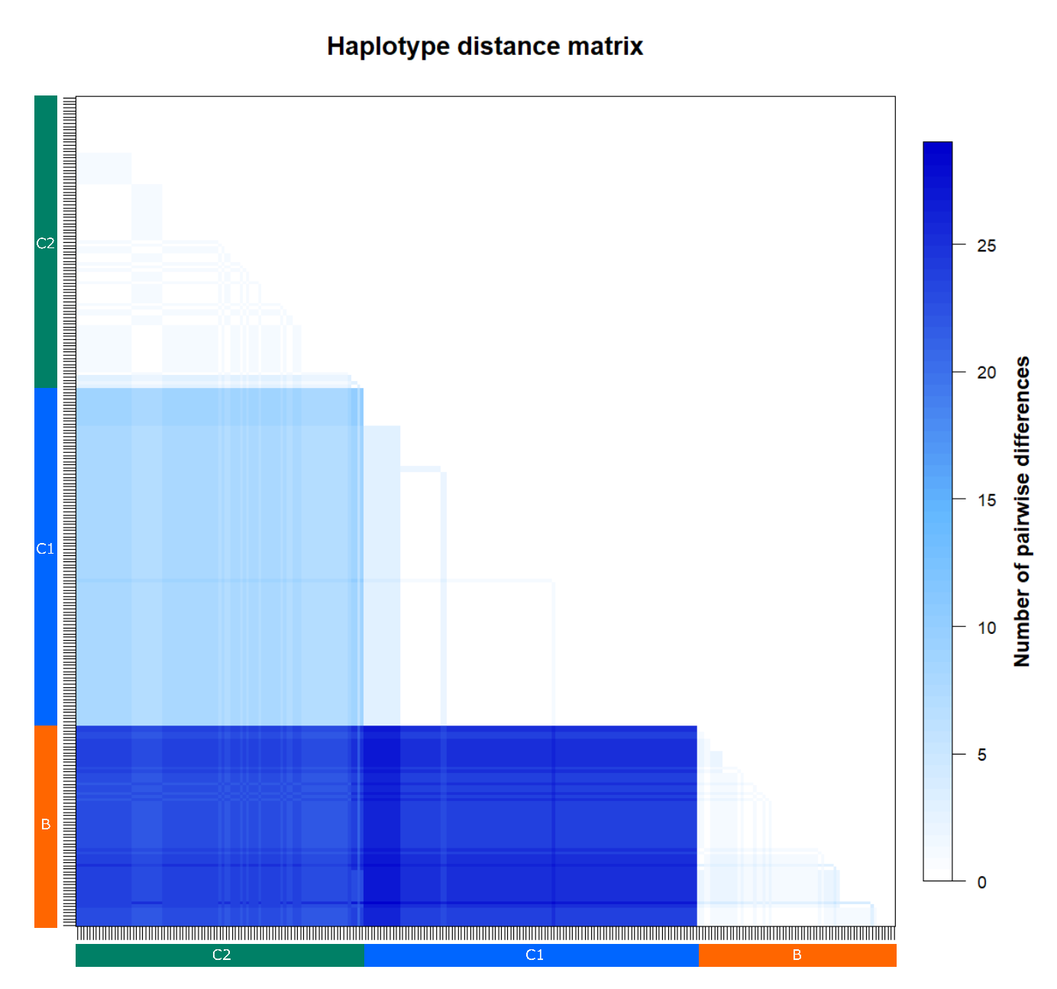
Supplementary Figure 5 – The haplotype distance matrix of 265 M. capaccinii samples.

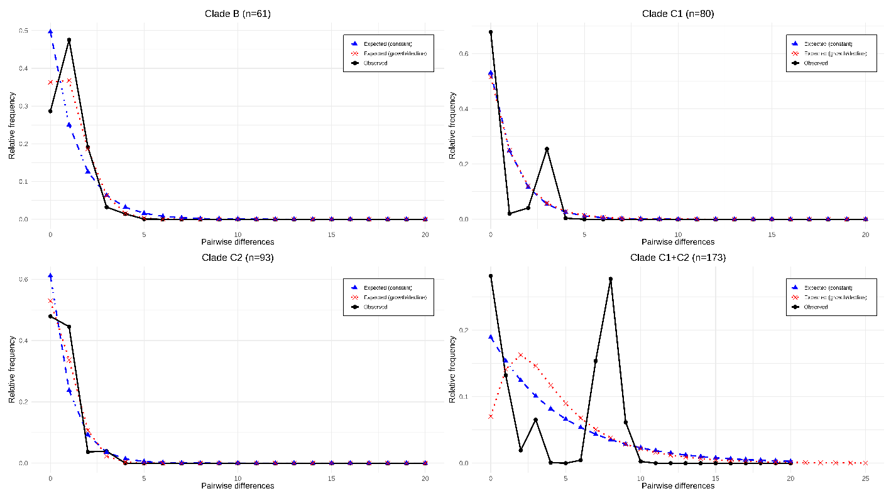
Supplementary Figure 6 – The observed and expected mismatch distributions in constant size and expanding population models for M. capaccinii clades B, C1, C2 and C (combined C1 and C2). The x-axis shows the number of pairwise differences between cyt-b haplotypes, and the y-axis represents the frequency of these differences. The raggedness index values are not significant (P > 0.05).

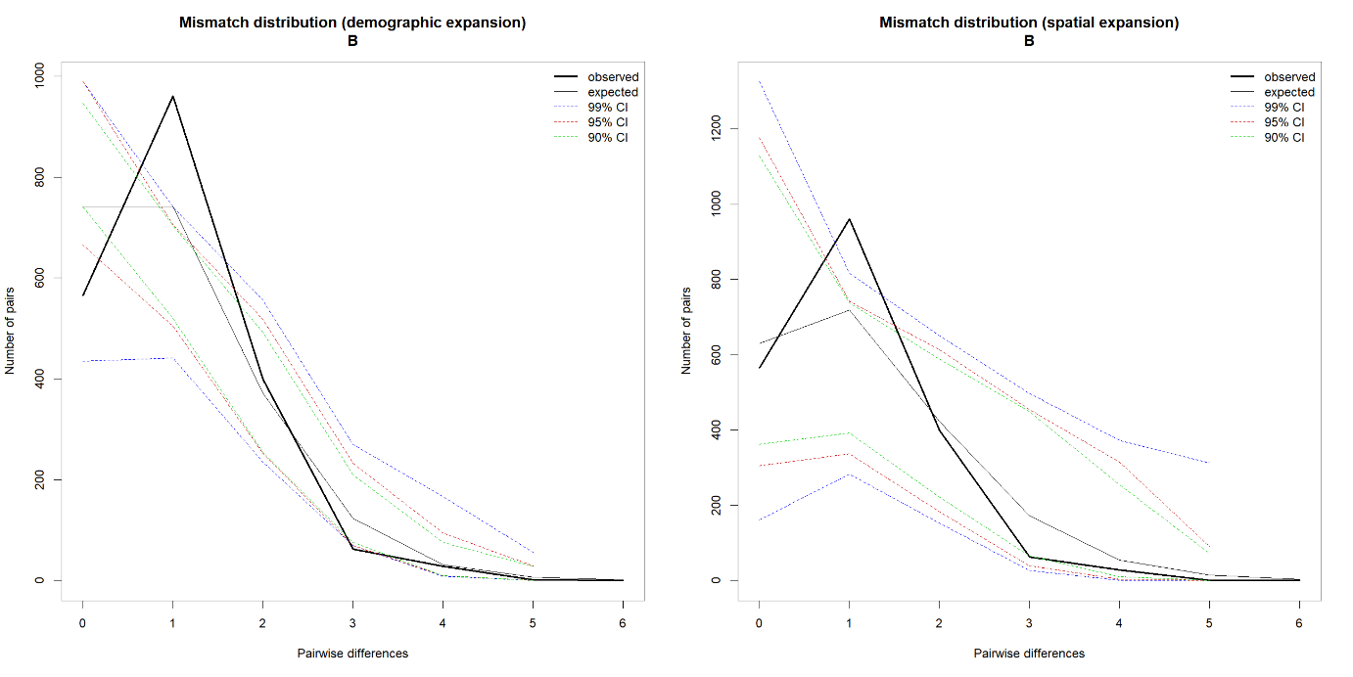
Supplementary Figure 7 – Observed and expected mismatch distributions under models of demographic and spatial expansions for clade B of Myotis capaccinii. A model of constant population size was rejected (99% confidence intervals of the mutation parameters θ₀ and θ₁, which are related to the effective size of the population before and after expansion, respectively, were not overlapping). For both the demographic expansion and spatial expansion models, the raggedness index (r) was 0.1447 (P < 0.001).

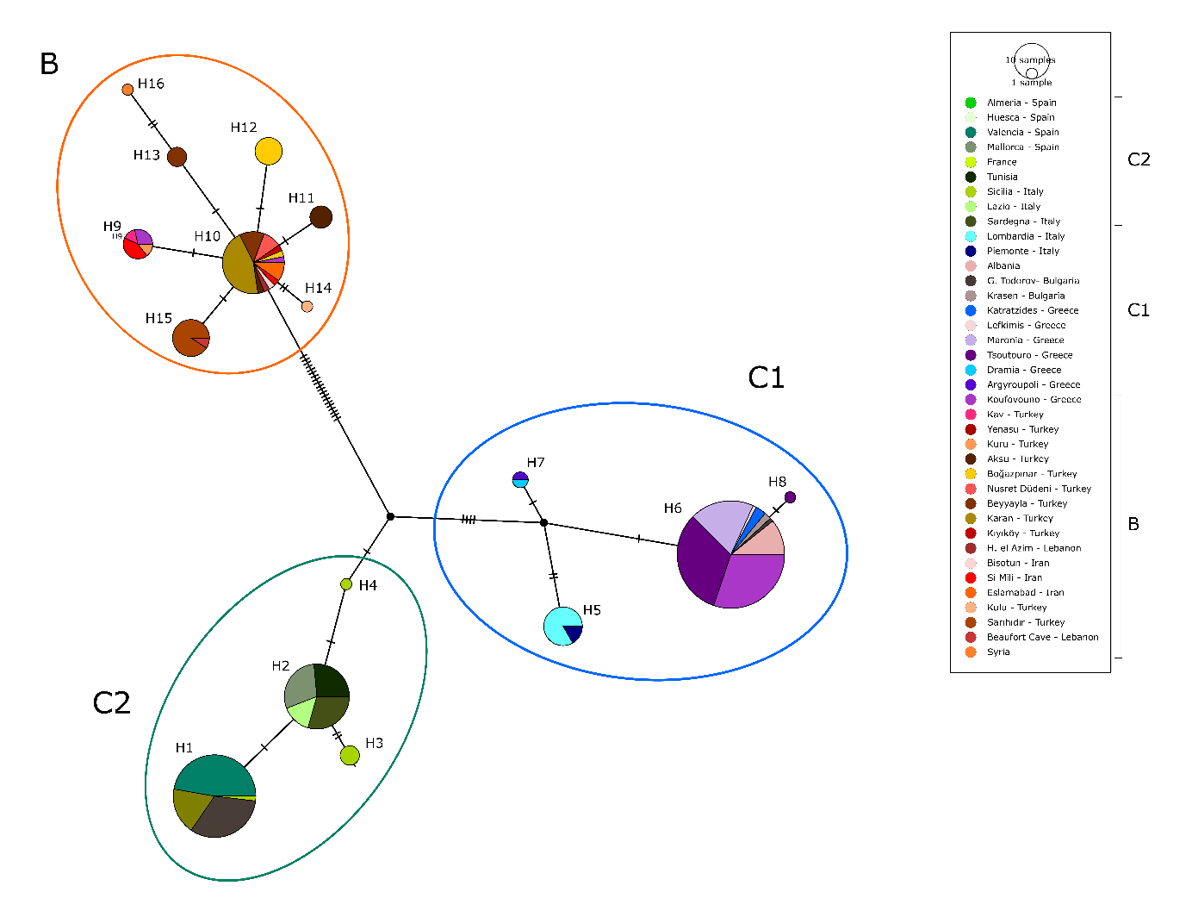
Supplementary Figure 8 – The haplotype network for 265 cyt-b sequences (671 bp) and their distribution based on 38 populations of Myotis capaccinii. The sizes of the circles are proportional to the frequency of the haplotypes they represent. The small dots stand for missing haplotypes.

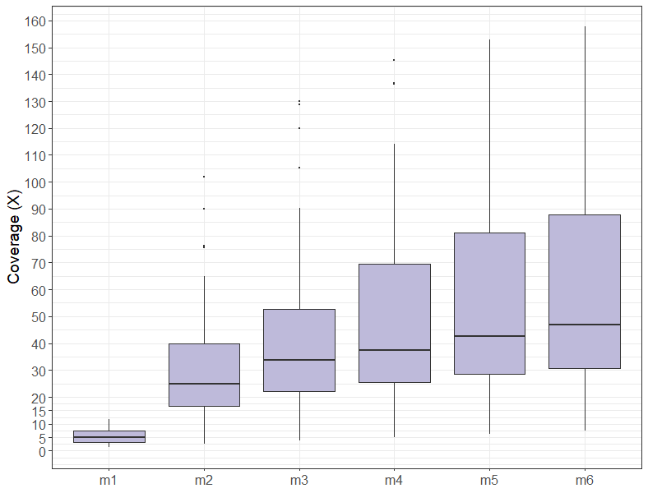
Supplementary Figure 9 – For visualization of optimization of de novo assembly of loci using STACKS, plot of mean coverage for the samples where each Myotis capaccinii individuals is represented as a box plot as mean coverage.

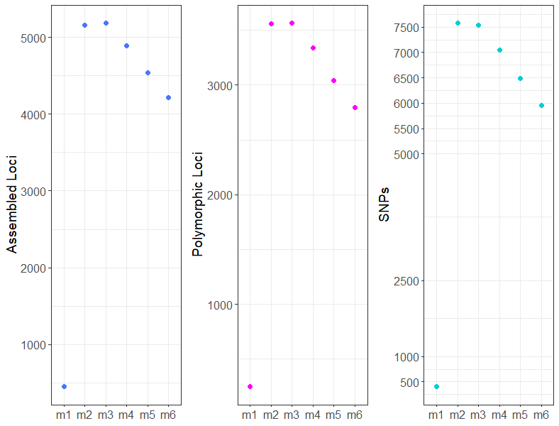
Supplementary Figure 10 – Plots of iterating values of minimum number of raw reads required to form a stack (m) for metrics: the number of Assembled loci; the number of Polymorphic Loci and the number of SNPs.

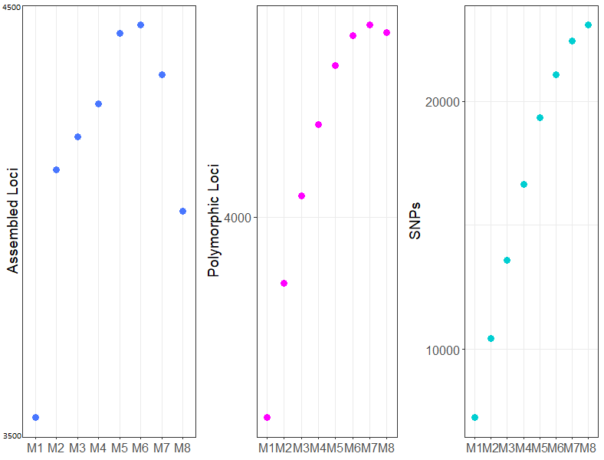
Supplementary Figure 11 – Plots of iterating values of minimum number of raw reads required to form a stack (M) for metrics: the number of Assembled loci; the number of Polymorphic Loci and the number of SNPs in Myotis capaccinii samples.

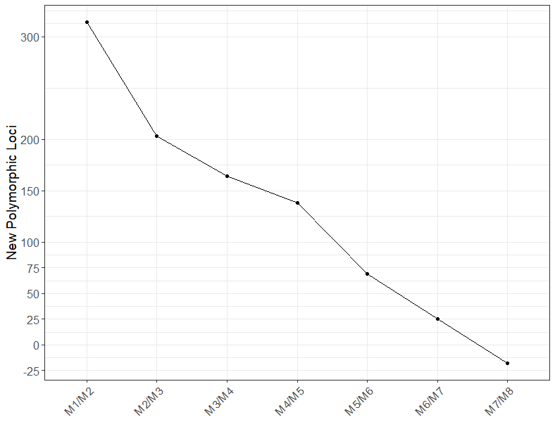
Supplementary Figure 12 – Plot of the number of new polymorphic loci added for each iteration of M (the distance between stacks) for the dataset.

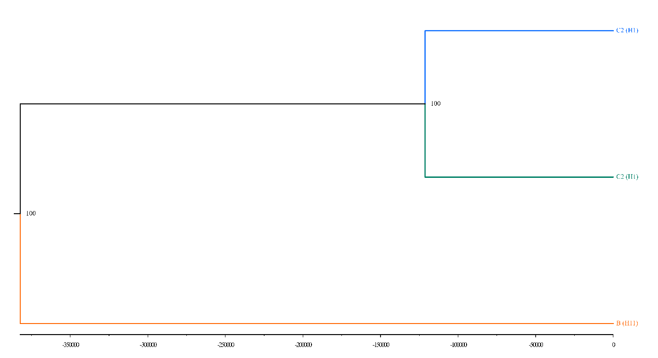
Supplementary Figure 13 – The divergence tree of the most common haplotypes of three haplogroups of Myotis capaccinii obtained using a strict molecular-clock with a rate of 4.8% divergence per million years. The units on the reverse scale axis are years.

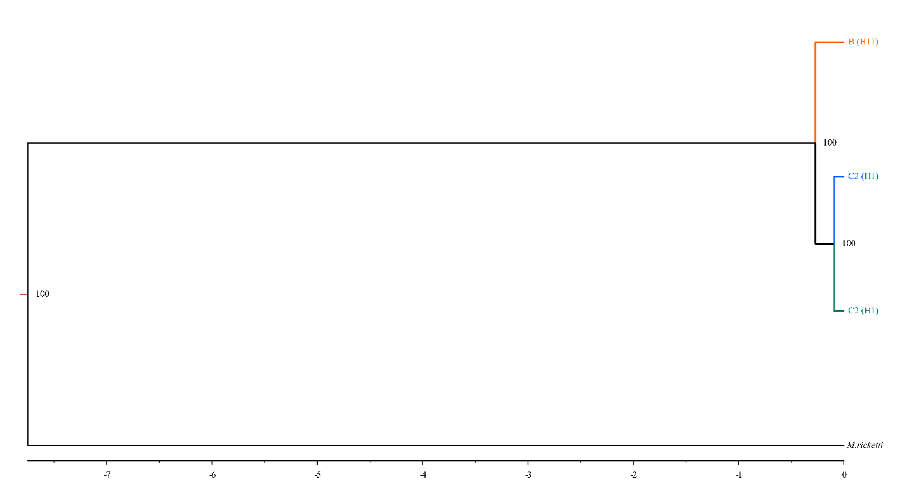
Supplementary Figure 14 – The divergence tree of the most common haplotypes of three haplogroups of Myotis capaccinii obtained using an uncorrelated relaxed clock and Myotis ricketti as an outgroup. The units on the reverse scale axis are million years.

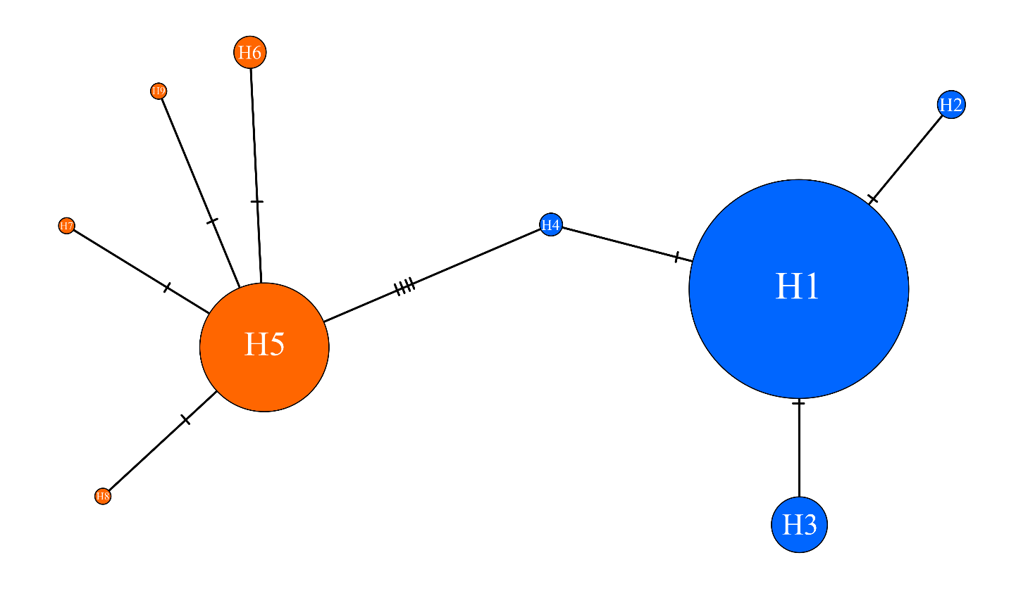
Supplementary Figure 15 – Statistical parsimony haplotype network based on a 205 bp overlapping segment of the cytochrome-b (cyt-b) gene, combining the 265 sequences generated in this study with eight sequences from Bilgin et al. (2008) (GenBank accessions EU475878.1–EU475885.1). Haplotypes belonging to clade B (including accessions EU475878.1–EU475884.1) are colored orange, whereas haplotypes corresponding to clades C1 and C2 (including accession EU475885.1) are colored blue. A complete list of samples and their corresponding haplotype assignments is provided in Supplementary Table 5. Due to the limited phylogenetic signal within this truncated overlapping region, the finer differentiation between clades C1 and C2 could not be resolved.

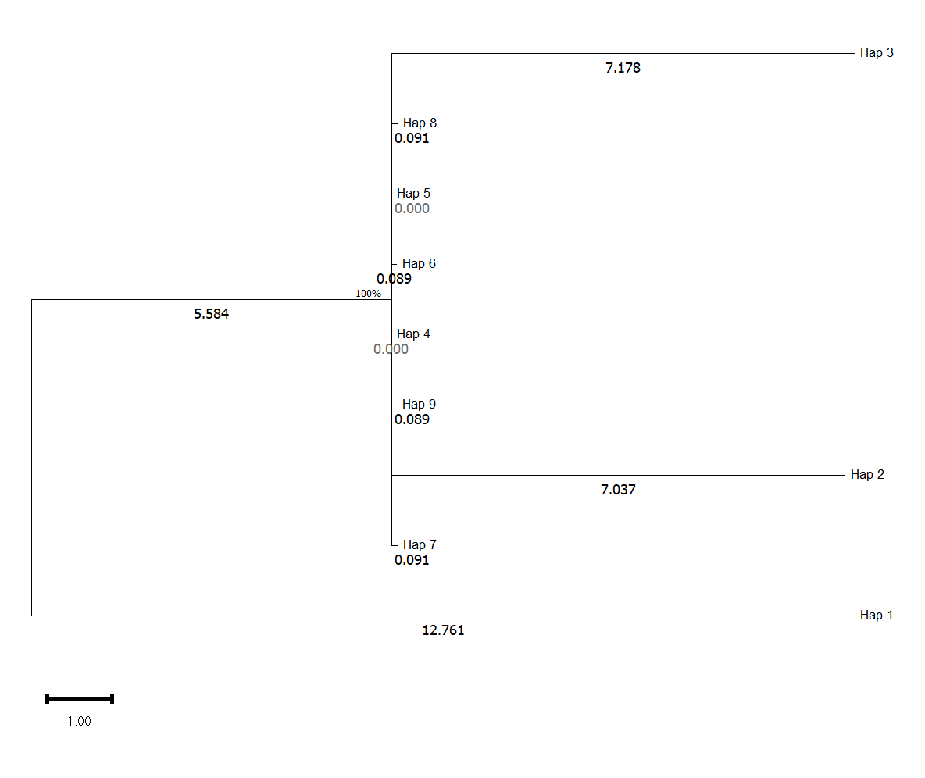
Supplementary Figure 16 – Maximum likelihood phylogenetic tree of Myotis capaccinii based on the 205 bp overlapping cytochrome-b (cyt-b) region, combining the 265 sequences generated in this study with the eight sequences from Bilgin et al. (2008). The tree was constructed using the 9 unique haplotypes (Hap_1–Hap_9) identified across the 273 analyzed samples (see Supplementary Table 5). The tree is drawn to scale, with branch lengths indicating the number of substitutions per site. A total of 11 variable sites were identified within the 205 bp alignment. As noted in the text, due to the short sequence length and limited phylogenetic signal, minor European C haplotypes (Hap_2–Hap_4) form an unresolved polytomy alongside clade B haplotypes rather than resolving into a distinct bifurcating clade.

