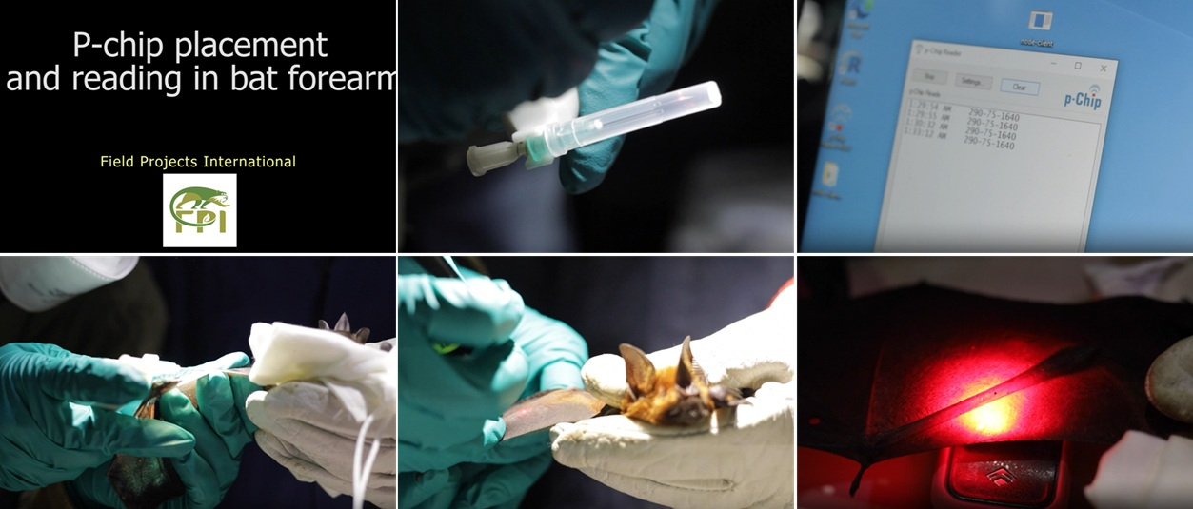
Video S1. Demonstration of p-Chip placement and reading in a free-ranging Phyllostomus elongatus at the Estación Biológica Los Amigos (Peru). Video was too heavy to upload in the platform. The image uploaded are just previews of the video. During the review process, it will be available at this link: https://drive.google.com/file/d/1pIHgsqXfBpOb7tb8dfRu0pJMNg88YSR5/view?usp=sharing

